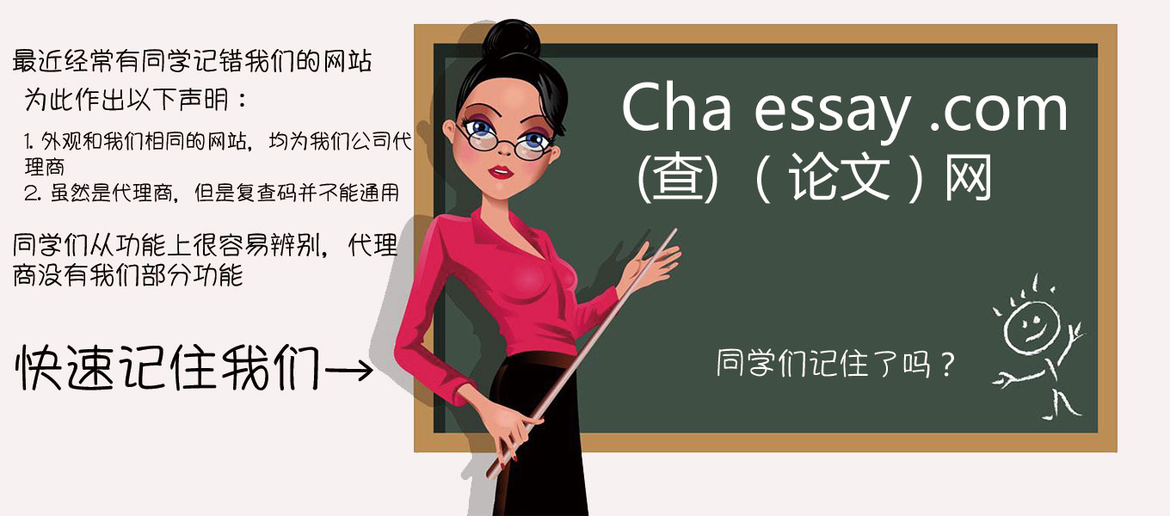
1、关于报告下载：
下载报告解压后，右键点击选择浏览器打开查看。如果打不开压缩包，请百度搜索解压软件。
（exclude bibliography）为排除参考书目和引用文献后的报告，（include bibliography）是包含。
2、检测报告说明：
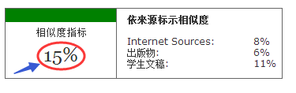
Similarity Index（相似度指标）：主要看相似度指标，如图相似度指标为15%
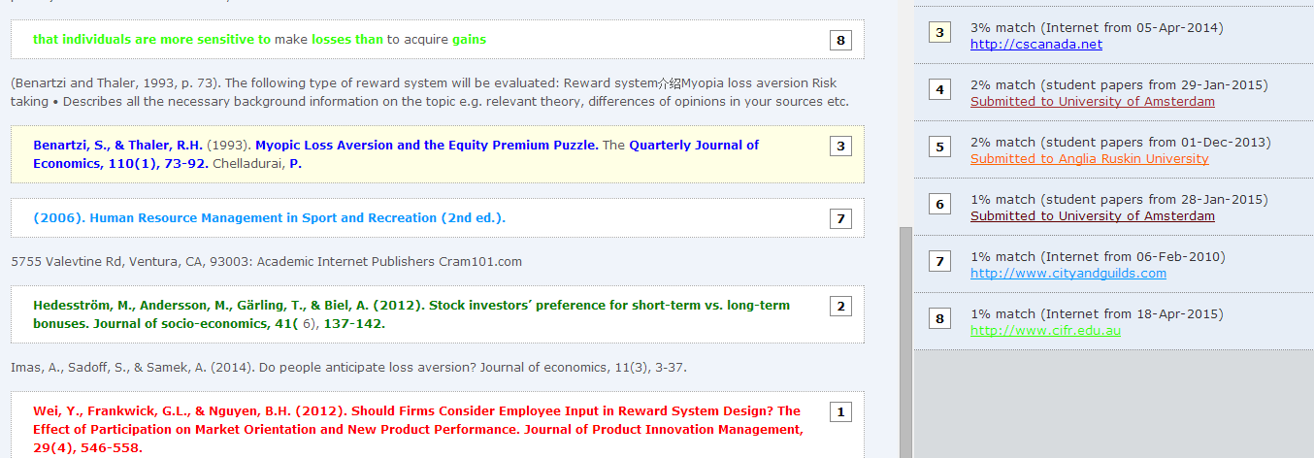
Similarity by Source（依來源标示相似度）：三处为比对数据库相似度，不是简单的叠加关系。相似度指标一般在10%以内为合格
黑色文字为合格的地方，其他带彩色部分是存在相似重复的地方，降低相似率必须修改带彩色部分；以上左边是原文，右边是相似来源，依照不同的相似来源，系统会将原文以不同颜色标示，并与左边相似来源也是对应上的，左右数字1，2，3是相对应的相似来源编号（上图原文编号8绿色重复来源是左边编号为8的文献相似度为1%）。右边的%比表示与文献单篇比对的相似度。

3、修改秘籍
由于turnitin采用模糊算法，如果整体结构和大纲被打乱，可能引起同一段落的文章检测前后标红不一致，这是正常的，所以请同学们在修改标红的时候尽量变换句式，不要打乱论文原来的整体大纲和结构。以下是常用到的几个修改方法。
1．报告原文有彩色的标记（例如红黄蓝绿等）就是相似重复的地方，需要修改的内容。
2．修改的时候不要简单删除一两个字，这样不是很管用，可以替换为同义词，断开句子
3．换表述，即换一种说法去表达被查出有相似的句字或者段落。
4．对句子结构进行合理转换，可降低修改之后文段与原有文段的相似比
5. 可以删除相似的的句子或者段落可以降低相似度
6. 将表格变成图片
7、如果引用部分被大量标重复，可以将直接引用改为间接引用，用自己的话表达，或者分多篇论文引用，同篇引用不超过20字。
8、把重复的参考来源文献做为引用来源，并正确标记引用。
修改范例：
相似段落：As for the fulfillment and control of the marketing strategies and marketing campaign, some invisible problems do exist. The biggest one is budget for a large sum of money is needed to maintain the original special entertainment activities , create some special events and festivals as well as increase brand awareness of Amsterdam. What is more, a lot of money must be spent on the advertisement and other promotional activities as a means of marketing campaign. In the meantime the local government has to invest a large quantity of money in transmitting British culture and related British law because its target customer is UK visitors. English is the preferred language, proper English such as advertising phrases and picture should be used in campaign design.Finally,support and acceptance from local citizens is also of great importance in creating a positive brand image of Amsterdam.

修改后：There are some potential issues with the implementation and control of the marketing strategies and marketing campaign. Budget is one of the biggest potential issues for implementing, keep the original special entertainment activities and then creating some new special events and festivals to increase brand awareness of Amsterdam will require a big amount of investment. In addition, marketing campaign also spend much money on advertisement and other promotional activities. At the same time, UK tourist is a target customer, English is the preferred language. Marketing campaign design should use correct English, suitable advertising expressions and pictures, need to respect British culture and comply with the British law. And local citizens' accept and support are very important for creating a positive brand image of Amsterdam.

Chaessy 查论文网 ,感谢您的支持。祝顺利！

